AMERICAN INTERNATIONAL UNIVERSITY OF BANGLADESH

Business Communication

Report Writing

Submitted to: **Borendra Lal Tripura**

**Assistant professor**

Student Name: Most Afroza Mahomuda

Id:20-43554-1

Section: K

Date: 16th April 2021

**Experimenting on the importance of carbon-dioxide in photosynthesis.**

**Abstract:**

**During the process of photosynthesis, cells use carbon dioxide and energy from the Sun to make sugar molecules and oxygen. These sugar molecules are the basis for more complex molecules made by the photosynthetic cell, such as glucose. It can be shown in this experiment.**

**INTRODUCTION:**

**Carbon dioxide is essential for the plants to sustain, as it is the carbon fixed from the carbon dioxide during photosynthesis is used for synthesizing glucose. This glucose is then later used during cellular respiration to make ATP, the energy molecule. Also, glucose is also used by plants as a vital source of carbon to produce a major part of the plant mass.**

**AIM:**

**show that carbon-dioxide is important for photosynthesis.**

**Hypothesis:**

**During the process of photosynthesis, cells use carbon dioxide and energy from the Sun to make sugar molecules and oxygen. These sugar molecules are the basis for more complex molecules made by the photosynthetic cell, such as glucose. Carbon dioxide when in its ionic form which is bicarbonate, has a regulating function in the splitting of water in photosynthesis, researchers have found. It is well known that inorganic carbon in the form of carbon dioxide, CO2, is reduced in a light driven process known as photosynthesis to organic compounds in the chloroplasts.**

**Risk Assessment: Avoid touching potassium hydroxide solution.**

**MATERIAL AND APPARATUS WE NEED:**

**Potted plant, 2 conical flasks, Soda lime, cork, Vaseline, water, iodine solution.**

**Method:**

**We take a potted plant having long and narrow leaves and place it in a completely dark place for; about three days to detach its leaves.**

**2. Take a glass bottle having a wide mouth and put some potassium hydroxide solution (KOH solution) in it.**

**3. Take a rubber cork which fits tightly into the mouth of the glass bottle and cut it into two halves.**

**4. Put a detached leaf of the potted plant in-between the two halves of the cut cork and then fit the cork in the mouth of the glass bottle. The upper half of the leaf should remain outside the glass bottle and only the lower half of the leaf should be inside the glass bottle.**

**5. The potted plant is kept in sunlight for 3 to 4 days. During this period, the upper half of the leaf gets carbon dioxide from the air but the lower half of the leaf does not get any carbon dioxide. This is because all the carbon dioxide of the air present in the glass bottle has been absorbed by potassium hydroxide solution. And no fresh air can come into the closed glass bottle.**

**6. Pluck the leaf from the plant and take it out from the glass bottle. Remove the green coloured chlorophyll from the leaf by boiling it in alcohol. In this way, we get a decolourised leaf.**

**7. Wash the decolourised leaf with water to remove any chlorophyll which may be sticking to it.**

**8. Pour iodine solution over the colourless leaf and observe the change in colour of the leaf.**

**9. We will find that the lower half part of the leaf does not turn blue-black on adding iodine solution showing that no starch is present in this lower half of the leaf. From this observation we conclude that the photosynthesis to make starch in the leaf does not take place without carbon dioxide.**

**10. The upper half part of the leaf turns blue-black on adding iodine solution showing that starch is present in this upper half of the leaf. From this observation we conclude that photosynthesis takes place in the presence of carbon dioxide. In other words, carbon dioxide is necessary for the process of photosynthesis to take place.**

**diagram of the experiment.**

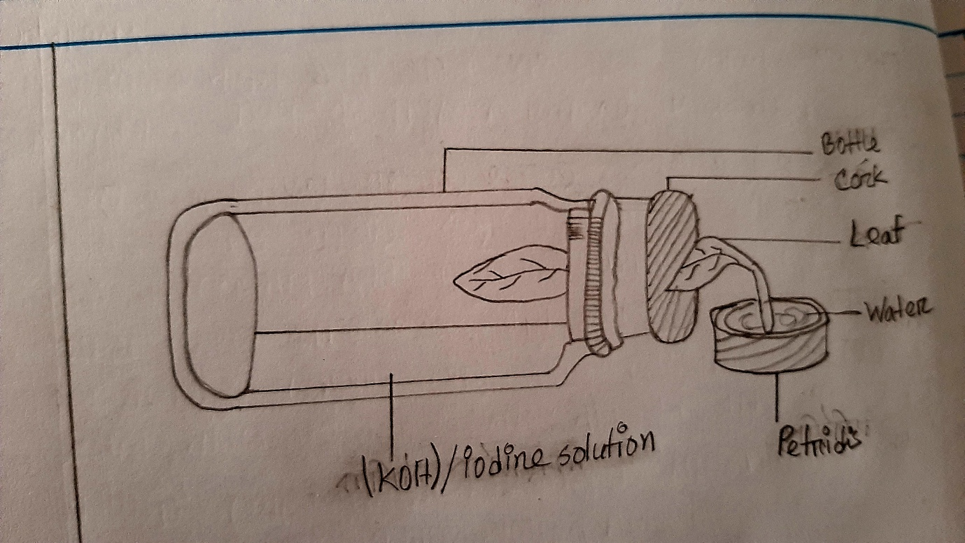

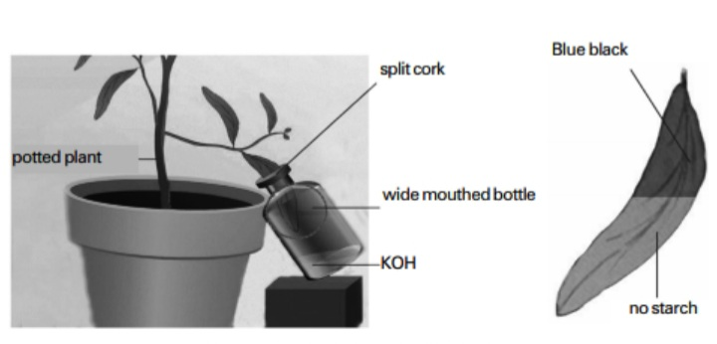

**Result : This experiment proves that CO2 is necessary for photosynthesis.**

**DISCUSSION:**

**(1) The part of the leaf kept inside the bottle should not touch potassium hydroxide solution.**

**(2) The apparatus should be kept air tight by applying grease or Vaseline.**

**CONCLUSION**

**Carbon dioxide is necessary for photosynthesis.**